Section 1

Section 1 is to be completed by the Tenant and submitted (in Word format) to the Tenant’s Port/ NWSA Representative for consideration. Refer to Tenant Improvement Procedure RE03 on the Port or NWSA website. Attaching all relevant documents & information, including drawings, approved permits, contractor scope of work, contractor estimate/quotes, will expedite the review process.

General Tenant Information
Company: |  | Date Submitted: | Click or tap to enter a date.
Address:
Contact Person: |  | Port/NWSA Real Estate Rep:
Contact Phone: |  | Port/NWSA Real Estate Rep:
Contact email: |  | Tenant Funding:  (select one) | 100%

Improvement Title:

Improvement Justification
Provide the justification/reason for completing the proposed improvements and anticipated impact to Port/NWSA assets.

Scope of Work
Describe in detail the proposed scope for an understanding and assessment of the project. Attach drawings, aerials, permits, contractor estimate/quote, contractor scope, etc. that will assist in explaining the location and intent of improvements.

Anticipated Schedule
Activity | Start Date | Completion Date

Design

Permitting

Construction

Estimated Cost of Improvements: | $

Agreement of Tenant
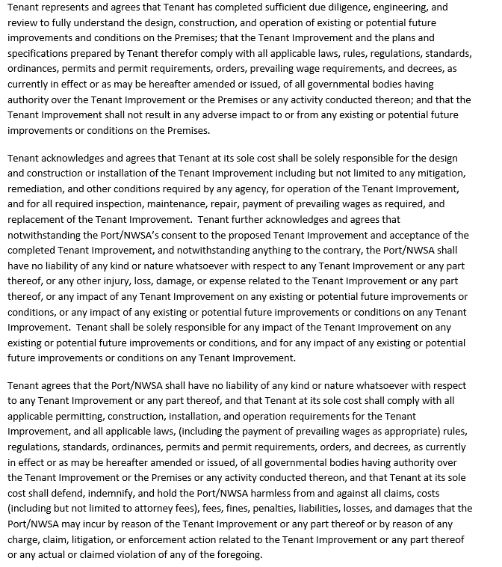

Section 2
Section 2 is to be completed by the Port/NWSA. Any items in the “requirements” sections must be completed by the tenant as noted by the reviewers.

General Information
**FOR PORT/NWSA USE ONLY**
Port/NWSA Representative:
Project Manager:

TIR ID No.

Recommendations
Items in this section are provided for informational purposes only and do not require any action by the tenant.
No. | Reviewer | Recommendation

<<Section intentionally left blank; requirements appear on the following page>>

Requirements Prior to Construction Approval
Tenant is required to fill out the “tenant response” section and return the request form. Approval to Proceed with Construction will not be granted until all requirements are met to the satisfaction of the Port/NWSA reviewer.
 |  |  |  | For Port/NWSA Use Only
No. | Reviewer | Requirement | Tenant Response | Approved By | Date
1
2
3
4
5

Requirements During Construction
All items must be completed during the construction phase. The tenant is responsible for providing all required documentation and coordinating any necessary inspections with Port/NWSA staff. All items in this section must be completed before Final Acceptance is granted.
 |  |  |  | For Port/NWSA Use Only
No. | Reviewer | Requirement | Tenant Response | Approved By | Date
1
2
3
4
5

Requirements After Construction
All items must be completed by tenant before Final Acceptance is granted.
 |  |  |  | For Port/NWSA Use Only
No. | Reviewer | Requirement | Tenant Response | Approved By | Date
1
2
3
4
5

Section 3
Section 3 is to be completed by the Port/NWSA.

Decision (select one)
Deferred for additional information
*Note: Tenant is not fully approved to proceed with the construction phase until the Port/NWSA receives the signed acknowledgement attached to this form separately.

Sr. Director, Engineering

